**Welcome Pack**

**Your Local Travel Information**

**Furlong Heights**

**What’s Inside?**

**Here’s your quick look reference for the different sections of your Welcome Pack**

**Page 2:** What’s Inside?

**Page 3:** Welcome Letter

**Page 4:** The Lavendon Travel Plan

**Page 5:** Environmental Damage of Car Use

**Page 6:** Benefits to You

**Page 7:** YourLocal Area

**Page 8:** Walking & Cycling

**Page 9:** Sustainable Transport Events

**Page 10:** Public Transport

**Furlong Heights**

Dear Furlong Heights Resident,

**Congratulations on moving into your new home!**

It is important to us that you settle in well to Lavendon and the local area and to do this we are pleased to provide you with your Welcome Pack.

As part of this pack, you’ll be introduced to the variety of local travel options that can provide you with excellent accessibility to your local area, including useful information on public transport services, as well as local walking and cycling routes in and around Lavendon.

This Welcome Pack is part of the on-going commitment Brampton Valley Homes has with the promotion of sustainable travel via the Travel Plan for Lavendon.

Kind Regards,

**Brampton Valley Homes**

**Furlong Heights**

**Residential Travel Plan**

Your development’s Travel Plan is here to promote and monitor sustainable travel used by Lavendon residents to:

* reduce the number of single occupancy car trips from the development.
* promote the use of public transport, cycling and walking.
* provide advice on how to improve local travel habits.

The success of the Travel Plan is down to you, the residents of this new community, and your enthusiasm to embrace changes in your travel habits for local journeys. The Lavendon Neighbourhood Plan has been developed to deliver the villages aspirations in relation to development, infrastructure, heritage protection, green spaces, and biodiversity enhancement until 2031.

To create your personal travel plan, head to https://getaroundmk.org.uk where you can access a variety of sustainable travel options in and around the Milton Keynes area.

For those aged 5 and 18, Milton Keynes Council is operating a Junior Concessionary Travel Scheme, the All in 1 MK Card, which gives card holders access to reduced bus fares on any service with a few exceptions. Please contact the Bus Card Section on 01908 252558 or email buscards@milton-keynes.gov.uk.

**Environmental Damage of Car Use**

Climate change, often referred to as Global Warming, is one of the greatest environmental threats facing the world today. When petrol, diesel or certain alternative fuels are burnt for energy in an engine the main by-products are water & carbon dioxide (CO2). Carbon dioxide, although not directly harmful to human health, is the most significant of the greenhouse gases contributing to climate change.

To reduce emissions, try the following eco driving tips:

* Avoid using your car for short journeys - use public transport, cycle, or walk.
* Cold starts - drive off as soon as possible after starting.
* Drive efficiently - harsh acceleration & heavy breaking have a very significant effect on fuel consumption.
* Reduce weight - don’t carry unnecessary weight, remove roof racks when not in use.
* Regular servicing helps keep the engine at best efficiency.
* Turn off your ignition when you are stationary for a period of time.

More info at: www.uk-global-roadsafety.com/top-ten-eco-driving-tips.php

**7 Benefits to You & Your Community**

Getting involved with the Lavendon Neighbourhood Plan has plenty of positive benefits including:

* Improve your health and wellbeing.
* Reducing your travel costs
* Improving your accessibility to local services
* Increasing your road safety
* Reducing your travel times
* Improving your travel choices
* Creating a cleaner, more vibrant local community

Our travel plan is a continuous process for improvement, requiring monitoring, review, and revision to ensure it remains relevant to our organisation and those using this site. This document sets out our proposals for monitoring and review of the travel plan over the next few years. This period is normally 5 years but could be longer in some situations.

**Your Local Area**

 A wide variety of amenities are located within the village, distance and walk times are presented in Figures 1 & 2 below. Further food, retail and other facilities are on offer in under mile away.

Figure 1: Destinations and Journey Times

|  |  |  |  |  |
| --- | --- | --- | --- | --- |
| **Amenity** | **Distance from site location (miles)** | | **Journey Time**  **(mins)** | |
| **Road** | **Footpath** | **Road** | **Footpath** |
| The Green Man PH | 0.4 | 0.4 | 2 | 8 |
| Lavendon Park | 0.5 | 0.5 | 2 | 10 |
| Tusting | 0.4 | 0.4 | 2 | 7 |
| Lavendon Village Hall | 0.4 | 0.4 | 2 | 7 |
| Convenience Store & Post Office | 0.3 | 0.3 | 2 | 5 |
| The Horseshoe PH | 0.4 | 0.4 | 2 | 7 |
| Maretts Mechanics | 0.6 | 0.6 | 3 | 11 |
| Lavendonmade | 0.4 | 0.4 | 2 | 7 |
| Sainsbury’s | 2.6 | 2.4 | 6 | 47 |

Figure 2: Local Amenities by car (source: Google Maps 2023)

**Walking & Cycling**

Furlong Heights is well connected to the rest of the village for both pedestrians and cyclists with most local amenities within a 0.5-mile radius.

There are currently no direct cycle paths between Lavendon and the nearest town and city, however there is a comprehensive variety of public transport connections between Northampton and Milton Keynes should you wish to leave the car at home.

Northampton is currently running an electric scooter hire scheme with Voi whilst Milton Keynes is operating a e-bike hire programme courtesy of Santander Cycles & Lime Bikes.

Whether you decide to hire or buy an e-bike, making that positive change can bring a variety of benefits including:

* No Road tax or insurance.
* No licence require, you can just get on and go.
* Bring in more exercise into your regular routine.
* Charge your bike at work for free fuel.
* Significantly reduce running and maintenance costs.
* Diminish CO2 emissions by an average of 408.5g per mile.

Figure 3: Travel around the vicinity of Lavendon (source: getaroundMK 2023)

**Sustainable Transport Events**

Stay fit and active by exploring the Milton Keynes area on foot. Head over to ramblers.co.uk and use their ‘Where do you want to walk?’ search feature by inputting your postcode or local area.

* Walk to School Week – 15th May 2023 to 19th May 2023 - https://getaroundmk.org.uk/events/walk-school-week
* National Walking Month – 1st May 2023 to 31st May 2023 - https://getaroundmk.org.uk/events/national-walking-month
* Bikeability Learn to Ride – 1st of every month – to book a place please contact andrew@chilterncyclehub.co.uk, £10 per person with no age restrictions.
* World Car Free Day - 22nd September 2023 - https://www.worldcarfree.net/wcfd

**Local Walks**

Keep fit and active by exploring the Lavendon area on foot. Visit https://www.walkingbritain.co.uk/find-walks-by-me.php to find a trail. Should you wish to find your own adventure, visit The Parish Copse, a haven for local wildlife.

Figure 4: The Parish Copse (source www.lavendoncpc.org)

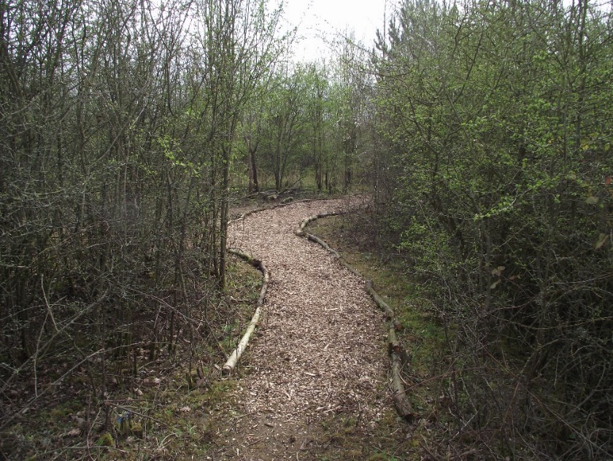

**Public Transport**

**Buses**

There are 2 bus stops near site, the closest bus stop is located by the village War Memorial (only 0.3 miles or 6 minutes away). The second is located along Olney Road (0.7 miles or 13 minutes away).

**Transport Links**

For timetables and further information please visit:

* www.stagecoachbus.com - Route 41 (runs twice daily)
* www.sharnbrookvillagerminibus.co.uk - Routes VL4 (2nd Tuesday of each month), VL5A (every Thursday) & VL7 (3rd Tuesday of each month) – all services to be booked in advance.
* www.redrosetravel.com - Route 21 (runs 3 times a day)

**Trains**

Lavendon is in a central location between 5 railway stations which are Bedford, Northampton, Wellingborough, Wolverton & Milton Keynes Central. The closest is Bedford, which is 9.5 miles away via the A428 and is accessible when combines with other modes of travel.

Please visit www.thameslinkrailway.com for timetable information.

**MK Connect**

Another travel option provided to residents is MK Connect, which is an accessible innovative ridesharing option for those living in areas not served by a bus route or when other choices are limited.

To book, please visit mkconnect.app.ridewithvia.com or call 01908 252526.

**Milton Keynes Park & Ride**

As driving to and parking in a town or city-centre can be expensive, the local authority offer a Park & Ride scheme to reduce the stress and the costs involved. With fares costing £2.40 for a day return per person or £5.00 for a group of up to 5 persons (adults & children) for the day.

Milton Keynes Park & Ride at MK Coach way offers 350 free parking spaces and is located on the east side of the city just off J14 of the M1 and the A509 with EV charging available. Figures 5 & 6 overleaf displays the inbound and outbound timetables for this service.

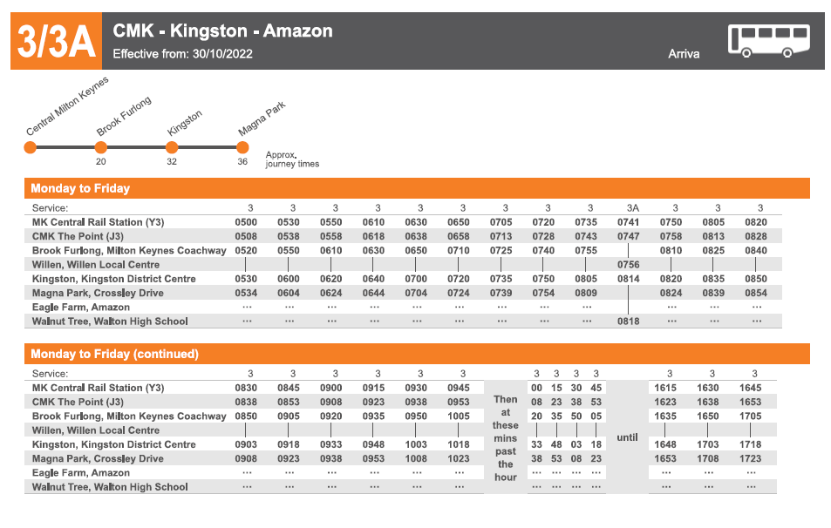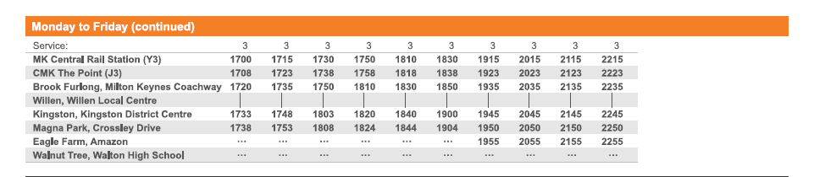

Figure 5: Milton Keynes Park & Ride Outbound Timetable

Figure 6: Milton Keynes Park & Ride Inbound Timetable

